A practical tool for SMEs employees
How to gather information and arguments for collective and wage bargaining

November 2022

Szilvia Borbély

Content

Introduction 3
1. Concepts 3
2 Recollecting arguments 6
Importance to recollect information and data for the argumentation 6
How to recollect, and where to find the information? (Sources of the data; national statistics, Eurostat, company data, balance sheets) 6
3 Recollecting information on the national economy – the indirect playground for the company 10
4 Recollecting data of the concerned sector according to 3-digit NACE 13
5. Recollecting data of the concerned sector on the EU level 15
6. Recollecting information on the state and play of the company 16
7. Bargaining – who bargains with whom? 17
8. How to bargain? 17
Strategies to bargain 17
9. Testing, comparing 19
10. Focusing on the own company – comparing the wages within the company 20
Examples of auxiliary tables to fill for setting internal company pay ratios 20
11. Focal points of the bargaining 26
Bibliography 27

Introduction

Wage negotiations in the workplace, to be successful, require serious preparation on the part of those involved - workers' representatives, trade unions, employees, etc... This guide tries to help with this.

The first step to wage bargaining in the workplace is to collect data (wages, income, productivity, headcount, etc.) for your own company, directly or indirectly related to payroll, broken down as needed - or as possible.

The second step in workplace wage negotiations is to collect labour market data to position the company. It's important to see where your company stands concerning other companies in your sector, sub-sector or specialism, the national economy as a whole, or even the EU or Member States of particular interest to you.

There are several sources of labour market data: in the EU, the Labour Force Survey, which collects data on the economic activity of the population (unemployment, employment), and the so-called institutional data collections. The latter is the basis for institutional labour force statistics compiled by the national statistical offices, covering enterprises with five or more employees, as well as budgetary and non-profit institutions. These data are provided by the statistical office in a breakdown that allows us to compare our company's data with the average of the economy/sector/industry; with our size category (employees below or above 250) and with the number of persons employed in that category, both manual and non-manual.

Concepts

Basic wage
Basic wage and salary is the personal basic wage or salary (hourly, weekly, monthly or yearly) of the employee, determined in his/her labour contract. This is the most important component of the worker's earnings.

Average earnings
Average earnings are computed by dividing the total sum of earnings for the reference period (hour, month, year,) by the average number of employees in the same period. If no alternative reference is indicated, data on average earnings presented in various publications refer to full-time employees.

Median wage/mean (average) wage
If all salaries were arranged in order, the median wage would be the one with exactly half the data above it and half below it. It contrasts with the mean wage, which is calculated by adding together all the salaries in a data set and dividing it by the total number of salaries.

Premium
Premium is a fixed sum paid to employees for performing pre-determined tasks.

Workplace bonuses
Bonuses and allowances are provided regularly for the compensation of special work conditions, special skills, special job requirements (unique circumstances at work), or non-common working time scheduling if these factors were not considered when determining the personal basic wage or the performance-based wage of the employee.

The most frequent bonuses and allowances defined by regulation (not denominated in the basic wage) are the following:
- bonuses for shift work (e.g. afternoon- or night-shift bonus),
- bonuses paid for the special circumstances of work (e.g. hot-workplace bonus),
- bonuses paid for special position or qualification (e.g. the leader's-, title-, and industrial bonuses of civil servants, bonus for special professional examination of government officials, bonus for special knowledge, leader's bonus of the district-notary, notary's bonus, foreign language bonus, etc.),
- overtime bonuses (including bonuses for working on rest days according to work schedule and on public holidays),
- bonuses for teaching apprentices and participants in retraining,
-- stand-by and inspection bonuses
- bonuses paid on special sites of installation and construction work,
- other bonuses determined by law or collective agreement (car-driving bonus, bonus for working among health risks).

Payments for time not worked
Payments for time not worked are remuneration, based on regulation by law concerning the employment relationship or according to a collective agreement, for the working time not performed. The concept means characteristically remuneration in case of absence. Such are:
- wage and salary paid for regular (basic annual or supplementary) and extraordinary leave, (i.e. holiday), including the remuneration paid if instead of being on holiday the employee was working and compensated by cash pay,
- wage and salary paid for study leave (or working time reduction obtained for studying purposes),
- remuneration for rest days and public holidays if the employee did not work on these days,
- if the employee did work on public holidays or rest days due to work schedule, then the remuneration for the day off that he/she got instead of the day worked,
- remuneration for making use of the working time reduction stipulated by regulation for trade union officials and factory council members,
- the additional part of the wage or salary of pregnant women assigned for eased work, which is to be paid to them by prescriptions of regulation to reach their previous earnings,
- additional wage or salary paid during working time-reduction for nursing (breastfeeding) mothers,
- wage and salary paid for breaks at work,
- wage and salary of employees sent on courses or study trips (chargeable to the employer),
- remuneration for the time spent on travelling in case of an official commission,
- wage and salary paid for employees on temporary "forced leave" due to the difficult economic circumstances of the employer or paid in the event of short-time working because of the ordered daily working time reduction,
- remuneration paid - upon agreement - by the employer for the period of strike,
- wage and salary for the working time lost as a result of a righteous denial of carrying out an order,
- remuneration for frost break,
- wage and salary paid in cases defined by the regulation when the employee is exempt from working obligation (e.g. remuneration of paid periods of absence during the fulfilment of civic duty or a compulsory medical examination).

Source: Central Statistical Office (KSH), Metainformation

Nominal wage/real wage
The nominal wage is the wage expressed in money, regardless of its purchasing power. Real wages, on the other hand, are the inflation-adjusted level of nominal wages, i.e. the number of goods and services that can be bought with wages.

Gross/net wage
In general, social security tax, health tax, pension contributions, unemployment contributions and personal income tax are deducted from the gross wage to get the net wage.

Attention! Payroll taxes and contributions (percentages) are subject to change from time to time! Always check the current values!

An example: Composition of wage cost in Hungary, 2022
Gross wage | Personal income tax | Social security contribution | Net wage | social contribution tax paid by the employer | Total Wage cost (Gross wage+social contribution tax paid by employer)
HUF | 15% | 18,5% | HUF | 13% | HUF
300 000 | 45 000 | 55 500 | 199 500 | 39 000 | 339 000

Tax wedge on the wage

The tax wedge is defined as the sum of personal income tax and employee and employer social security contributions net of family allowances, expressed as a percentage of total labour costs (the sum of the gross wage and social security contributions paid by the employer).

Calculation of the tax burden on the wage: sum of all tax and contribution burdens/wage cost*100=
45000+55500+39000)/339000) = 41%.

In 2020 this value was in Hungary at 43%, Portugal at 41% and Turkey at 39.7%; the OECD countries' average was much lower, at 34%. (Source: OECD Taxing wages 2021).

2 Recollecting arguments

Importance to recollect information and data for the argumentation

Without proper data, it is impossible to bargain.
The first step in workplace wage negotiations is to get as much and as much detail as possible about the company's performance and the wages, to collect any data that are directly or indirectly related to the wage bargaining (wages, earnings, productivity, headcount, etc.), with the deepest breakdown as possible (blue collar/white collar workers, managerial/non-managerial staff, full time/part-time workers, permanent/contract workers, breakdown by age, education and not at last by sex.
The second step is to gather labour market data that will allow you to position your own company. It is important to see where your firm stands concerning other firms in your sector, sub-sector or specialisation, in the national economy as a whole, or even concerning the EU or some of its Member States of particular interest to you.

How to recollect, and where to find the information? (Sources of the data; national statistics, Eurostat, company data, balance sheets)

Company data must be made available by the management to the employees and their negotiators (trade union, works council). The available public balances also provide a lot of information on the possible limits of the bargain.

A public database of balance sheets and reports
In Hungary, after entering a few details (company name or company registration number or tax number), you can search for the mandatory publication of company accounts and balance sheets on the company information portal run by the Ministry of Justice. The web address of this site is as follows: https://ebeszamolo.im.gov.hu/oldal/beszamolo_kereses

National Statistical Offices
Also, there are several sources of national, sectoral, and subsectoral labour market data: as we already told, the Labour Force Survey, which collects data on the economic activity of the population (unemployment, employment), and the so-called institutional data collections. The latter is the basis on which for example the central statistical office in Hungary compiles its institutional labour statistics, which cover enterprises with at least five employees and full-fledged budgetary and non-profit institutions of employment importance.

EUROSTAT – EU Statistics
At the European level, we can also consult the EUROSTAT database. EUROSTAT provides detailed information on labour costs, wages, employers' social security contributions and much more for all EU Member States. Some direct links to the EUROSTAT database on our topic:

https://ec.europa.eu/eurostat/web/labour-market/labour-costs/main-tables
https://ec.europa.eu/eurostat/web/labour-market/labour-costs/database

Information is available in English, German and French.

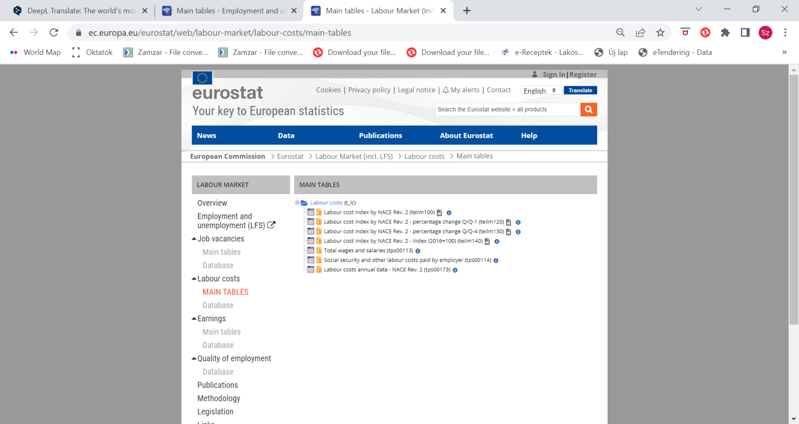

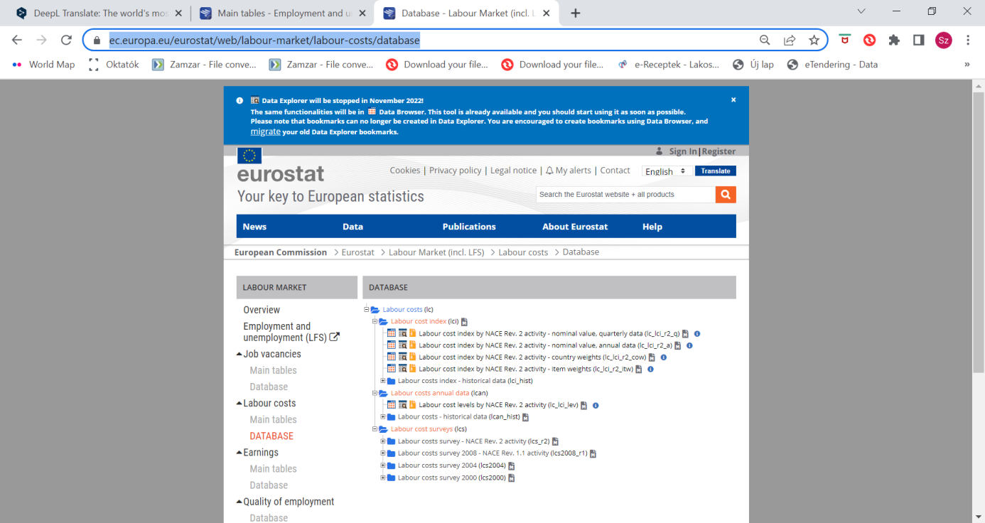

International Labour Organisation (ILO) wage statistics:
https://ilostat.ilo.org/topics/wages/
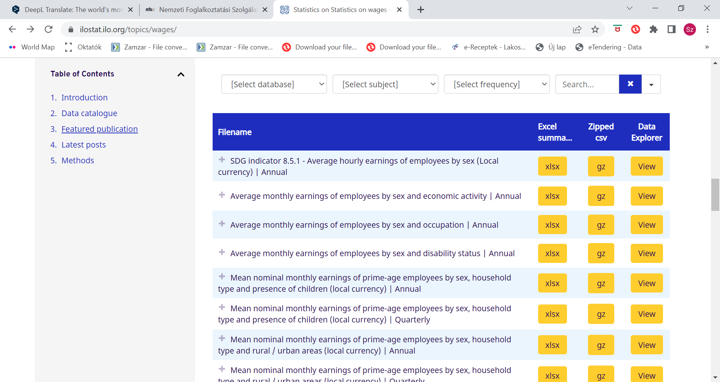
OECD statistics
https://data.oecd.org/earnwage/average-wages.htm
Alternative data sources
The reliability of these sources is questionable, often based on self-reported surveys. They also emphasize that the data are for information purposes only and are a public database of reports.

Alternative sites for international comparison are like:
https://www.averagesalarysurvey.com/hu/

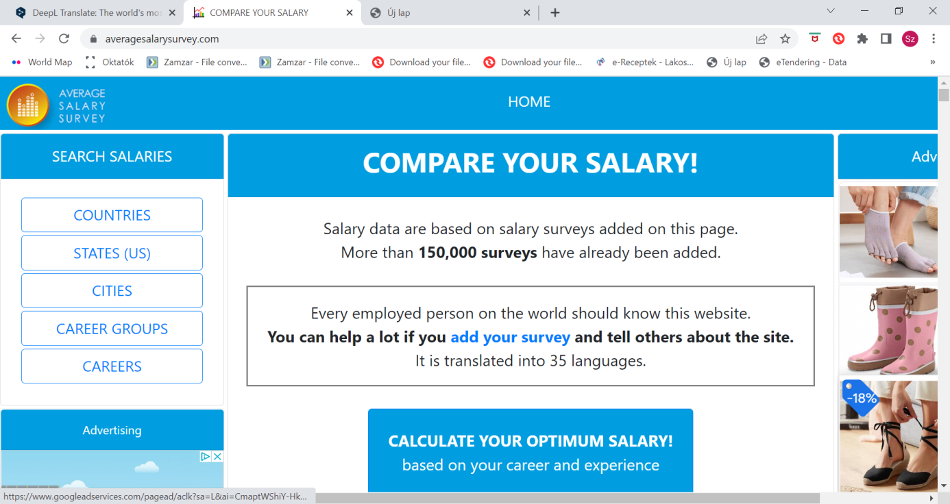

https://wageindicator.org/salary/salary-survey

Recollecting information on the national economy – the indirect playground for the company

Where do our company and its performance stand compared to other companies in the national economy?

What are the indicators we should look at?

Productivity
Consumer Price Index- inflation
Company’s Annual Report (income statement, balance sheet, financial statement, cash flow report, etc.)
Wage – average/median wage (last available year/month) and latest trends (latest nominal and real wage trends, 2-5 years)
Income – wage and other payments, average/median income (last available year/month) and latest trends (latest nominal and real income trends, 2-5 years)
National minimum wage (latest) if any
Labour market (Unemployment- vacancies, age distribution; fluctuation; migration)

Productivity
Whether looking at the national economy as a whole or the firm level, workers can claim a share of productivity growth. And, assuming a constant level of employment, an increase in the output of the economy or firm means an increase in productivity. Of particular importance for us is the evolution of labour productivity, i.e. the output per unit of labour (either for the economy as a whole or for a firm).

Indicators to look for:
Evolution over time of Gross Domestic Product (GDP) per employed person
Evolution over time of Gross Domestic Product (GDP) per hour worked

At the firm level, one of the most widely accepted indicators for assessing performance is the income earned by firms over a given period.

Measuring labour productivity (quantitative measurement): how many parts, applications, products or calls a worker can process per hour, day or month. Some software measure and calculate average daily production or the productivity of each employee per hour, day or month (e.g. nTask, Basecamp, Asana, etc.)

Consumer price index - an indicator of inflation, money depreciation
Another important component of wage claims is the increase in prices and the decline in the purchasing power of the national currency. Inflation above 10% per year is called galloping inflation. The central statistical offices measure domestic inflation using a consumer basket of several hundred goods and services. However, the composition of the basket is problematic in that it does not adequately reflect the consumption of families in different life situations. For some time now, for example, the Hungarian Central Statistic Office has also been measuring a separate price index for pensioners, which naturally excludes items that can be linked to childcare, for example.

In wage negotiations, demanding a wage increase in line with inflation means that workers' living standards in real terms will only remain at the same level. It should also be taken into account that the consumption structure of different strata differs substantially, as does their cost of living.

Trends in the company's performance, profitability, efficiency, assets and financial position - based on the company Annual Report, the profit and loss account and the balance sheet

Indicators can be either status indicators for a given year or process indicators showing the dynamics of several years.

Performance indicators
The company profit and loss account provide information on the performance (success) and income-generating capacity of the company over a given period.

Annual result = annual revenue (turnover) divided by expenses (costs)

Measures of performance
- net sales revenue
- profit after tax

Performance-related ratios
- net sales per employee
- profit after tax per equity

Profitability indicators
The most commonly used indicators of corporate profitability are ROE and ROA.
- Return on equity (ROE) - Return on equity (after tax profit/average equity) - shows the profitability of capital - the higher the value, the better the profitability of capital.
- Return on Assets (ROA) - Return on Assets (profit after tax/average assets) - the higher the value of the indicator, the higher the return on assets of the company

Efficiency indicators
- Inventory turnover rate: net sales/inventories
- Net sales per capita: net sales/average number of employees

Capital structure and indebtedness indicators
They provide a picture of the company's assets and liabilities (e.g.: the ratio of fixed assets; the ratio of liabilities).

Liquidity indicators
They allow us to conclude the financial situation of the company (liquidity ratio, liquidity quick ratio).

Liquidity ratio= Current assets/short-term liabilities
- If the indicator is less than 1 the company is insolvent
- A value of around 1,5 to 1,8 is acceptable
- The company's creditors (mainly short-term creditors) favour a higher liquidity ratio.

Liquidity quick ratio = Current assets - inventories / current liabilities
- If the ratio is greater than 1, it means that the firm can settle its liabilities due within the year from its assets that can be turned into cash relatively quickly

Mandatory minimum wage
This can have a positive pull effect in general (you cannot pay less than this). However, sometimes a negative wage effect has also been observed; employers finance the cost of the mandatory minimum wage increase by not increasing the wages of others accordingly. If the wage bargain is weak, there is a risk that a significant proportion of workers' wages will be stuck around the minimum wage, pulling down median or average wages.

The European Union directive adopted in autumn 2022 proposes two methods for Member States to set the minimum wage:
- create a real-price consumer basket of locally available goods and services;
- Use a benchmark, set at 60% of the median gross wage or 50% of the average gross wage.
Member States should also establish a procedural framework for setting the minimum wage on the basis of clear criteria and updating it at least every two years (every four years for countries using an automatic indexation mechanism).

Labour market (Unemployment - vacancies, age distribution; turnover; migration, etc.)
The evolution of the labour market, the supply and demand for a given occupation, can have a significant impact on the bargaining process, as there is a greater chance of negotiating better wages in times of labour shortages than when workers are facing redundancy for whatever reason.

Fill in the following table to get a view to start!

 | My company data | National level data
Wage dynamics
Nominal wage change compared to the previous year
Real wage change compared to the previous year
Nominal income change compared to the previous year
Real income data change compared to the previous year
Performance dynamics
Change in sales (turnover) compared to the previous year
Change in export sales compared to the previous year
We are also looking for answers to the following questions:
Inflation - do the wage/salary dynamics in my company exceed or not the inflation?
Minimum wage - do the wage/earnings dynamics experienced in my company exceed or not the increase in the minimum wage/guaranteed minimum wage?
How does the average/median wage in my company compare to the minimum wage/guaranteed minimum wage?
The European Parliament and the EU Member States June 2022 reached a political agreement on the Directive on adequate minimum wages proposed by the Commission in October 2020 (’Proposal for a DIRECTIVE OF THE EUROPEAN PARLIAMENT AND OF THE COUNCIL on adequate minimum wages in the European Union COM/2020/682 final’).

The European Parliament Committee on Employment and Social Affairs adopted the Directive in July 2022. In September 2022 the European Parliament approved the Minimum Wage Directive with an overwhelming majority. Member States with statutory minimum wages will need to put in place a sound governance framework for setting and updating minimum wages. This includes – among others - clear criteria for minimum wage setting (including the purchasing power taking into account the cost of living; the level, distribution and growth rate of wages; and national productivity.

The directive proposes that member states use the reference values of 60% of the gross median wage or 50% of the gross average wage.

You can consult the text of the directive in several languages on the following link:
https://eur-lex.europa.eu/legal-content/EN/TXT/?uri=CELEX%3A52020PC0682

4 Recollecting data of the concerned sector according to 3-digit NACE

Where do our company and its performance stand compared to other companies in the sector?

What should we do to get an answer?

Find out the company’s NACE in 1/2/3 digit depth (What is NACE - Statistical classification of economic activities?)Link to the NACE classification: https://ec.europa.eu/competition/mergers/cases/index/nace_all.html

Wage-income data in the sector
Wage – average/median wage (last available year/month) and latest trends (latest nominal and real wage trends, 2-5 years) in the sector/subsector (according to 3-digit NACE if possible)

Income – wage and other payments, average/median income (last available year/month) and latest trends (latest nominal and real income trends, 2-5 years) in the sector/subsector (according to 3-digit NACE if possible)

Sectoral minimum wage if any

Characteristics of the labour market in the sector.
Trends (decreasing/increasing number of employees). Main professions in the sector. Unemployment/lack of labour in the sector. Age structure/education level structure

Social dialogue in the sector
Sectoral wage/collective agreement if any.

5. Recollecting data of the concerned sector on the EU level

Where do our company and its performance stand compared to other companies in the EU/selected countries in the sector? (This section has particular importance in case of the company producing for export or in case of high cross-country labour force fluctuation)

We should look for:

Average/median wage (last available year/month) and latest trends (latest nominal and real wage trends, 2-5 years) in the sector/subsector

 | Company data | EU level or data for selected countries (e.g. where the firm's export activity is predominantly directed) | Value of my company as a percentage of the EU/selected countries, %
Average wage
Median wage
Average wage change relative to the previous year
Median wage change relative to the previous year

6. Recollecting information on the state and play of the company

Where do we stand and what space do we have to bargain?

  - Performance of the company (present state and latest trends)
  - Strategic plans of the market – plans for change
  - The market for the output of the company – state of play of the market; export or domestic market
  - Import content of the product – state of play of the market of import products
  - Reading the balance sheet
  - The wage information of the company (average wage, median wage; breakdown according to professions, education level, age groups, gender, manager/non-manager status, and all other available data).

  - Income and its usual composition in the company

    - overtime compensation
    - evening or night-work compensation
    - the premium for hardship work
    - the premium for Sunday work
    - seniority allowance
    - holiday bonus
    - Christmas bonus
    - 13., 14. months wage
    - extra-payment related to the company’s performance
    - other non-wage allowances – commuting – transport allowance
    - meal allowance/meal voucher
    - other vouchers

  - State of play of the company’s staff (number, distribution according to age, education, profession, gender)
  - Collective/wage agreement in the company

7. Bargaining – who bargains with whom?

Wages can be determined in a variety of ways.

ILO (2003) makes the following differentiation
1. negotiations between workers and their employer as:
- individual agreements
- collective bargaining agreements
2. between workers and employer representatives as collective bargaining agreements
3. intervention/inclusion of third parties in the negotiation and/or determination of wages, by:
- conciliation
- mediation
- arbitration
- industry boards or other organizations

8. How to bargain?

Strategies to bargain

There are some tips:

If you bargain you should:
- Become familiar with industry salary trends.
- Build your case.
- Tell the truth.
- Factor in perks and benefits.
- Practice your delivery.
- Know when to wrap it up.
- Get everything in writing.
- Stay positive.
(Source: Half, R. (2022)

Hard and soft bargaining strategies
One approach is that bargaining can be hard and soft bargaining. In soft bargaining, the goal is to reach an agreement, in hard bargaining the goal is to win. Soft bargaining is characterised by making concessions, and hard bargaining by demanding concessions. Soft bargaining is driven by trust and hard bargaining is by mistrust. (Roger Fischer és William Ury: Getting to Yes

Principled strategy
In principled negotiation, negotiators rely on objective criteria—a fair, independent standard—to settle their differences. For example, they might agree to abide by standards such as market value, expert opinion, industry protocol, or the law.

Cooperative-style
Negotiators with a primarily cooperative style are more successful than hard bargainers at reaching novel solutions that improve everyone's outcomes. Negotiators who lean toward cooperation also tend to be more satisfied with the process and their results. (Source: Staff, P. (2020))

The ILO suggest for the bargaining employers’ side consider the following phases
1. Opening the Meeting
2. Confirming Common Ground and Narrowing the Gap
3. Making Proposals
4. Responding to Proposals
5. Questioning and Listening
6. Bargaining, Movement and Solution Building

9. Testing, comparing

Fill in the following table to get a view to start!
The relative position of my company

Wages/Income | Value of my company in the percentage of the EU/selected countries value, % | Value of my company in the percentage of the sectoral value, % | Value of my company in the percentage of the national value, %
Average wage
Median wage
Average Income
Median Income
The average wage, blue-collar workers
The median wage, blue-collar workers
Average-income, white-collar workers
Median income, white-collar workers
The average wage, man
The median wage, man
Average income, man
Median income, man
The average wage, women
The median wage, women
Average income, women
Median income, women

The income includes the following items: basic pay + -
-
-
-
-
-

10. Focusing on the own company – comparing the wages within the company

Relative wage/income position of white-collar/blue-collar workers
Relative wage/income position of workers in the headquarters/rural sites
Relative wage income of managers/non-managers
Relative wage/income of workers according to education level
Relative wage/income of male/female in the same category
Wage/income dynamic (change) over a certain period (5 years, 2 years, 1 year, etc.) according to the availability of the dates

Examples of auxiliary tables to fill for setting internal company pay ratios

Average basic wage (monthly, yearly), blue collar, white collar workers, headquarter, rural sites, state of play, dynamics and in-house differences

Average basic wage in the company, state and change, blue collar
 | 2019/  2018 | 2019/  2018 | 2020 /2019 | 2020 /2019 | 2021 /2020 | 2021 /2020 | 2022 1st semester/2021 first semester | 2022 1st semester/2021 first semester
 | Headquarter | Rural site | Headquarter | Rural site | Headquarter | Rural site | Headquarter | Rural site
Average basic wage, in national currency or EUR
Average basic wage change, %

The difference in the wage of blue-collar workers in the headquarter and the rural site -
(average basic wage of blue collars at headquarters minus the average basic wage of blue-collar workers at the rural sites)
 | 2019/  2018 | 2020 /2019 | 2021 /2020 | 2022 1st semester/2021 first semester
Average basic wage, in national currency or EUR

Company average basic wage, state and change, white collar
Average basic wage | 2019/  2018 | 2019/  2018 | 2020 /2019 | 2020 /2019 | 2021 /2020 | 2021 /2020 | 2022 1st semester/2021 first semester | 2022 1st semester/2021 first semester
 | Headquarter | Rural site | Headquarter | Rural site | Headquarter | Rural site | Headquarter | Rural site
Average basic wage, in national currency or EUR
Average basic wage change, %

The difference in the wage of white-collar workers in the headquarter and the rural site -
(average basic wage of white collars at headquarters minus the average basic wage of white-collar workers at the rural sites)
 | 2019/  2018 | 2020 /2019 | 2021 /2020 | 2022 1st semester/2021 first semester
Average basic wage, in national currency or EUR

Difference between the average basic wage of white-collar and blue-collar workers, in national currency or EUR (White collar average basic wage minus blue-collar average basic wage)
 | 2019/  2018 | 2019/  2018 | 2020 /2019 | 2020 /2019 | 2021 /2020 | 2021 /2020 | 2022 1st semester/2021 first semester | 2022 1st semester/2021 first semester
 | Headquarter | Rural site | Headquarter | Rural site | Headquarter | Rural site | Headquarter | Rural site
White collar
Blue collar
Difference

% change in the difference between basic wages of blue-collar and white-collar workers compared to the previous year, %
 | 2019/  2018 | 2020 /2019 | 2021 /2020 | 2022 1st semester/2021 first semester
Headquarter, %
Rural site, %
(It is calculated from the ‘Difference’ value of the previous table)

Average earnings (monthly, yearly), blue collar, white collar workers, headquarter, rural sites, state of play, dynamics and in-house differences

Average (monthly) earnings = basic wage + time-related bonus + job-related bonus + other bonus, premium

Average earnings in the company, state and change, blue collar
 | 2019/  2018 | 2019/  2018 | 2020 /2019 | 2020 /2019 | 2021 /2020 | 2021 /2020 | 2022 1st semester/2021 first semester | 2022 1st semester/2021 first semester
 | Headquarter | Rural site | Headquarter | Rural site | Headquarter | Rural site | Headquarter | Rural site
Earnings, in national currency or EUR
Earnings change, %

The difference in the earnings of blue-collar workers in the headquarter and the rural site -
(average earnings of blue collars at headquarters minus the average earnings of blue-collar workers at the rural sites)
Average earnings | 2019/  2018 | 2020 /2019 | 2021 /2020 | 2022 1st semester/2021 first semester
Average earnings, in national currency or EUR

Company average earnings, state and change, white collar
average earnings | 2019/  2018 | 2019/  2018 | 2020 /2019 | 2020 /2019 | 2021 /2020 | 2021 /2020 | 2022 1st semester/2021 first semester | 2022 1st semester/2021 first semester
 | Headquarter | Rural site | Headquarter | Rural site | Headquarter | Rural site | Headquarter | Rural site
average earnings, in national currency or EUR
Average earnings change, %

The difference in the average earnings of white-collar workers in the headquarter and the rural site -
(average basic wage of white collars at headquarters minus the average basic wage of white-collar workers at the rural sites)
Average earnings | 2019/  2018 | 2020 /2019 | 2021 /2020 | 2022 1st semester/2021 first semester
Average earnings, in national currency or EUR

Difference between the average e earnings of white-collar and blue-collar workers, in national currency or EUR (White collar average earnings minus blue-collar average earnings)
Average earnings | 2019/  2018 | 2019/  2018 | 2020 /2019 | 2020 /2019 | 2021 /2020 | 2021 /2020 | 2022 1st semester/2021 first semester | 2022 1st semester/2021 first semester
 | Headquarter | Rural site | Headquarter | Rural site | Headquarter | Rural site | Headquarter | Rural site
White collar
Blue collar
Difference

% change in the difference between average earnings of blue-collar and white-collar workers compared to the previous year, %

Average earnings | 2019/  2018 | 2020 /2019 | 2021 /2020 | 2022 1st semester/2021 first semester
Headquarter, %
Rural site, %
(It is calculated from the ‘Difference’ value of the previous table)

The trend in average basic wage and average earnings growth relative to each other

% change in the difference between basic wage and average earnings of blue-collar and white-collar workers compared to the previous year, %

 | 2019/  2018 | 2019/  2018 | 2020 /2019 | 2020 /2019 | 2021 /2020 | 2021 /2020 | 2022 1st semester/2021 first semester | 2022 1st semester/2021 first semester
 | Headquarter | Rural site | Headquarter | Rural site | Headquarter | Rural site | Headquarter | Rural site
Average basic wage development, blue collar, %
Average basic wage development, white collar, %
Average earnings development, blue collar, %
Average earnings development, white collar, %
Here we recommend creating graphs for better visualization.

Looking for the pay gap between managerial and non-managerial white-collar workers

If we can obtain data in concern of managerial wages it is useful to make a comparison between the wages of the managerial and non-managerial white-collar workers, both in concern of their average basic wage and their earnings. Several conclusions can be drawn about the company's reward and bonus policy.

2022 I. semester (or latest available data) | Headquarter | Headquarter | Rural site | Rural site
 | Non-managerial white collar | managerial white collar | Non-managerial white collar | managerial white collar
Basic wage
Earnings
Difference between earnings and Basic wage, in National currency
Average basic wage in the % of average earnings

The elements that typically determine the earnings of non-managerial and managerial staff, in addition to the basic salary, in national currency or EUR
,
 | Headquarter |  | Rural site
2022 Ist semester or latest available data | Non-managerial white collar | Managerial white collar | Non-managerial white collar | Managerial white collar
Average time-related bonus
Average job-related bonus
Bonuses together
Average premium

The elements that typically determine the earnings of non-managerial and managerial staff, in the percentage of earnings, in %
,
 | Headquarter |  | Rural site
2022 Ist semester or latest available data | Non-managerial white collar | Managerial white collar | Non-managerial white collar | Managerial white collar
% of time-related bonus in earnings
% of job-related bonus in earnings
% of bonuses together in earnings
% of premium in earnings
% of basic wage in earnings
Total (earnings) | 100% | 100% | 100% | 100%

11. Focal points of the bargaining

Based on the results, what should we focus on in the bargaining process?
Choose some aspects which may be defensible arguments during the bargaining.

1)

2)

3)

4)

5)

Bibliography

Fisher, R., Ury, W. and Patton, B. (1991), Getting to Yes: Negotiating Agreement without Giving In, 2nd ed., Houghton Mifflin.

KSH Methodology, www.ksh.hu

Half, R. (2022) How to Negotiate Salary After You Get a Job Offer? https://www.roberthalf.com/blog/salaries-and-skills/be-ready-for-salary-negotiations-with-these-8-tips

ILO (2003) Collective bargaining and negotiation. A resource book for employers. https://www.ilo.org/wcmsp5/groups/public/---asia/---ro-bangkok/---ilo-jakarta/documents/publication/wcms_120206.pdf

Staff, P. (2020) Negotiation Skills: Which Negotiating Style Is Best? 02/11/2020, https://www.pon.harvard.edu/daily/negotiation-skills-daily/negotiation-skills-which-negotiating-style-is-best/

Vanicsek, Zoltánné (2021) GINOP-5.3.5-18 „Munkaerőpiaci alkalmazkodóképesség fejlesztését célzó tematikus projektek megvalósításának támogatása” GINOP-5.3.5-18-2019-125 - Munkaerőpiaci alkalmazkodóképesség fejlesztése és az átmenet támogatása a „B” Bányászat, kőfejtés ágazatban. Szociális partnerek és együttműködésük fejlesztésének lehetséges útjai” „B” Bányászat, kőfejtés ágazatban, különös tekintettel a munkaerőpiaci átmenetre

