Circular economy in the textile industry
A theoretical and practical guide on the possibilities and place of circular economy in the textile industry

November 2022

Szilvia Borbély

Content

Introduction 4
The concepts 4
The traditional linear and the circular economy 4
Options for waste management in the textile and garment sector 6
Reusing 6
Recycling 6
Pre-and post-consumer waste 6
Downcycling and/or upcycling 7
Reuse or recycle? 7
Environmental assessment of the planned investment. The environmental benefits of reuse and recycling 7
The environmental benefits of reuse and recycling 7
The product's carbon footprint (PCF) and life cycle assessment (LCA) 8
Environmental impact assessment. How do we find out our possible environmental impact? A way to asses 12
What can we do? Places to look for materials and ideas 13
What to do with our waste? How to find useful waste for my company? 14
Textile waste and available technologies for textile waste treatment in Hungary 14
The practice of ECO-labels 15
EU-Ecolabel 15
OEKO-tex label – MADE IN GREEN 18
GOTS (Global Organic Textile Standard) 20
EMAS (Eco-Management and Audit Scheme 21
Textile label 21
Bibliography 22
Legal regulation 23

Introduction

The textile industry accounts for 10% of global carbon emissions and is reported to be the second most polluting sector in the world. The European textiles sector is predominantly made up of SMEs, 88.8% of which are micro-enterprises (less than 10 employees). The high negative environmental impact of the textile and fashion industry is a major concern. However, very few textile and fashion SMEs are actively involved in reducing their negative environmental footprint, even though they are aware of the problems because they lack the skills and knowledge of the cycle.

’…an effective EU strategy for sustainable textiles requires consideration of the entire value chain, to ensure that the textile industry recovers from the COVID-19 crisis sustainably and competitively. Indeed, the value chain of production, the consumption of raw materials and the lifecycle of the textiles are decisive stages for the sustainability of the end product. Moreover, the greatest sustainability potential lies in the use cycle.
The upcoming strategy should, therefore, include a clear plan to eliminate factors that prevent SMEs from moving to more sustainable business models. It should support businesses that already apply circular economy and provide helpful tools, conducive framework conditions and technical support for those who face difficulties with the implementation of greener business models.
Sustainability criteria should already be applied during the product design stage to ensure that textile end products remain in use for a long time, can be recycled and thus reduce waste.’ (Source SmeUnited, in Lena, G. (2021)

The fashion and textile industry is rapidly changing, thanks to new materials and solutions. It is important to equip small businesses here, who would otherwise find it more difficult to access these individually, with the tools, skills and knowledge to learn about circular economic models and to adopt them in their professional practice, to move from a linear business model to an ethical and circular business model. This will enable them to run more innovative businesses, making them more competitive at the international level, and to become socially, environmentally and financially stronger and more sustainable.

The concepts
What we should know about the concepts?

The traditional linear and the circular economy

In a traditional linear economy, raw materials are extracted or cultivated and then processed into a product that is discarded after use.

The textile industry traditionally follows this model, with the main stages being:
- Extraction/cultivation (Raw material producing phase)
- Manufacturing (Industrial phase)
- Distribution, use, maintenance (Consumer phase)
- Landfill/incineration (End of life phase)

A circular economy is fundamentally different from a linear economy. In a circular economy, the cycles of raw materials are closed. Closing these cycles requires much more than just recycling.

The circular economy is a model of production and consumption that includes reuse, repair,
up-grading and recycling of existing materials and products to keep materials in the economy wherever and whenever possible.

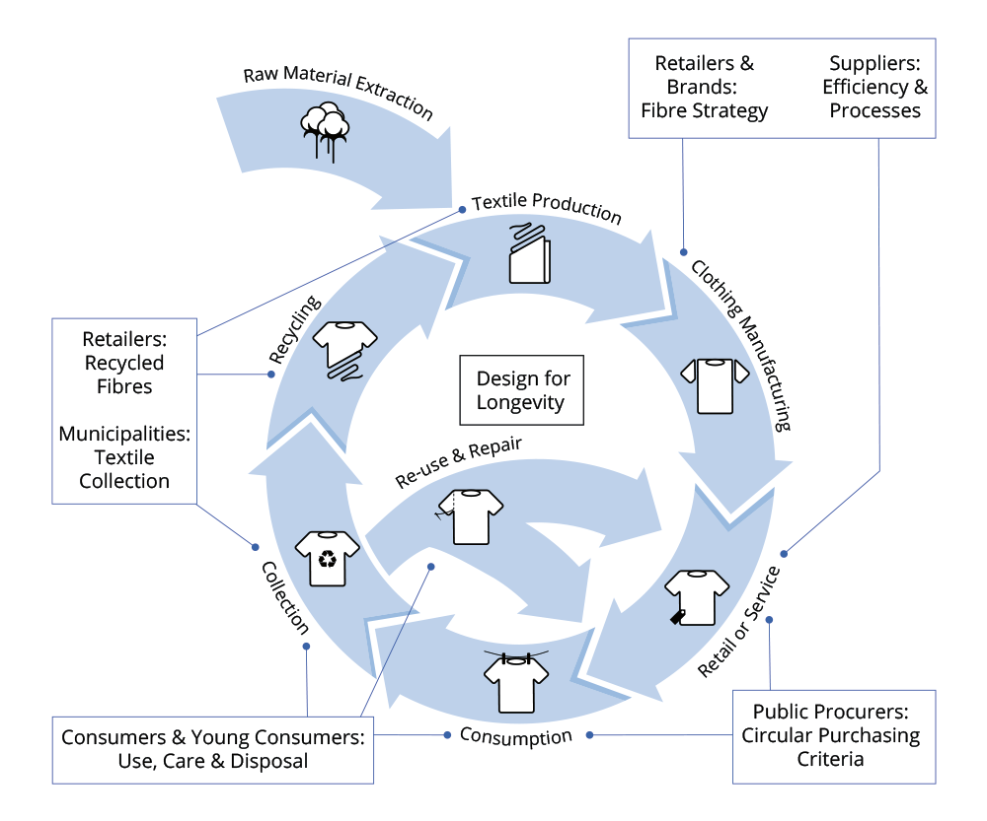
The circular model in the textile/garment industry
Source: https://www.circularcityfundingguide.eu/circular-sector/textiles/

Options for waste management in the textile and garment sector
As regards the management of used textiles and clothing, there are options like including them in household waste and placing them in residual waste bins. The larger quantities are collected centrally and treated in recycling centres run by municipalities. Their use is free of charge for citizens, but companies may have to pay a certain fee. Used textiles and second-hand clothes can be collected by private companies or charities (e.g. Red Cross) too.

Reusing
Textile reuse refers to various means for prolonging the practical service life of textile products by transferring them to new owners (L.M. Fortuna, V. Diyamandoglu (2017)), with or without prior modification (e.g. mending).

Recycling
Recycling should be the last option, just before the garbage can. (Engels) It is because reusing is among others less expensive, it uses less energy and it causes less (or no) pollution than recycling.

Textile recycling most often refers to the reprocessing of pre- or post-consumer textile waste for use in new textile or non-textile products. That is, textile recycling is the method of reprocessing used clothing, fibrous material and clothing leftovers from the manufacturing process. The textile's composition and design largely affect its reuse or recycling potential. The application of recycled material is especially non-woven.
The ways of recycling can be mechanical or chemical or less frequently thermal. Chemical recycling most often means dissolving the textile waste into its basic chemical building blocks (a recycling route in which the polymers are depolymerised or dissolved). Mechanical recycling is done by unravelling discarded textiles into fibres (small, thin threads) and subsequently using that recovered fibre material (often mixes of original fibres and colours) to spin a yarn. If necessary partially with virgin fibre, depending on the recovered fibre quality and yarn specifications.

Pre-and post-consumer waste

Pre-consumer waste
We have to make difference between pre-consumer and post-consumer waste. Pre-consumer waste includes fibre and yarn waste, cutting waste during garment manufacturing, and unsold stock from brands, wholesalers and retailers. These materials are recycled into new – especially non-woven - raw materials to be used in furniture, felt material for car insulation, roofing felts, loudspeaker cones, panel linings, home furnishing, mattress fillings, paper industries, etc...

Post-consumer waste
Post-consumer waste is worn out, outgrown, etc. garments or textiles discarded after use. They are partly reused by charities or sold in second-hand shops; partly they are thrown away in the regular trash. This latest has a negative environmental effect as they end in a low-standard waste dump or incineration fire

Downcycling and/or upcycling
Other classifications of recycling routes are when the recycled material is of lower value (or quality) than the original product, this is termed downcycling. Today, existing textile recycling routes are in most cases downcycling. Clothing and home textiles are down-cycled into, for example, industrial rags, low-grade blankets, insulation materials and upholstery. In contrast, if a product from recycled material is of higher value (or quality) than the original product, it is termed upcycling. (Gustav, Sandin & Greg M., Peters (2018))
In general, during recycling, the fibres will gradually decrease in quality and ultimately end up in waste disposal or incineration (down-cycling).

Reuse or recycle?
According to the findings of Gustav Sandin & Greg M. Peters (2018) a) textile reuse and recycling, in general, reduce environmental impact compared to burning and landfilling, and b) reuse is more beneficial than recycling, because reusing is among others less expensive, it uses less energy and it causes less (or no) pollution than recycling. ‘For those of us looking to care for the planet, we need to get back to reuse. And, when items can’t be reused, we need to find ways to repurpose them.

Environmental assessment of the planned investment. The environmental benefits of reuse and recycling

Environmental assessment of textile reuse and recycling is already in use. The environmental impact of a new project/investment should be identified and assessed. Are textile reuse and recycling always beneficial in terms of environmental impact? Authors most often assume that textiles sent for recycling are environmentally friendly waste and that recycled products and products made from recycled materials are substitutes for products made from new fibres.

However, Gustav Sandin & Greg M. Peters (2018) find that this is not always the case as “benefits mainly arise due to the avoided production of new products, benefits may not occur in cases with low replacement rates or if the avoided production processes are relatively clean. Also, for reuse, induced customer transport may cause an environmental impact that exceeds the benefits of avoided production, unless the use phase is sufficiently extended.”

The environmental benefits of reuse and recycling
- Reduces landfill space requirements (incineration also requires space).
- Less new material and non-renewable resources are needed.
- Generally less pollution and energy use than when producing from new raw materials.

The following questions arise:
Does the use of the circular model contribute to reducing the relevant negative environmental impacts of waste?
What will be the environmental burden of a product made from recycled waste?
How clean is the production process of the new product and/or the product made from recycled material?

The product's carbon footprint (PCF) and life cycle assessment (LCA)
To measure the environmental impact of the planned investment in practice, it is necessary to calculate the product's carbon footprint (PCF), which is one of the most important environmental indicators, and the product's life cycle assessment (LCA).

Product's carbon footprint (PCF)
The textile industry is increasingly involved in measuring carbon emissions as part of policy development and product design.

What is the Corporate Carbon Footprint and how to calculate it? (Source: Görkem Gencer (2022))

’Companies release greenhouse gas (GHG) such as carbon dioxide, methane, and hydrofluorocarbons into the atmosphere during manufacturing, transportation, or other business activities. The carbon footprint of a company accounts for both the direct and indirect GHG emissions of the company.
- Direct GHG emissions: GHG emissions can be the result of company actions that come from facilities owned by the company. For example, if a fossil fuel power plant burns coal to generate electricity or a factory releases CO2 while producing goods as a by-product these count as direct GHG emissions.
- Indirect GHG emissions: The companies that use intermediate or final goods for their operations indirectly cause GHG emissions because the production and transportation of these goods emit a certain amount of GHG. Supplier emissions, electricity consumption for the company’s operations, and waste disposal all fall into this category.’
‘The carbon footprint is measured by multiplying unit of business operation (e.g. gallons of gasoline) with operation-specific emission factor (which is equal to 8,887 times 0,001 metric tons CO2/gallon for gasoline according to the US Environmental Protection Agency. So, for instance, a field sales team that consumes 13503 gallons of gasoline per month for transportation purposes creates a carbon footprint of approximately 120 tons per month.’
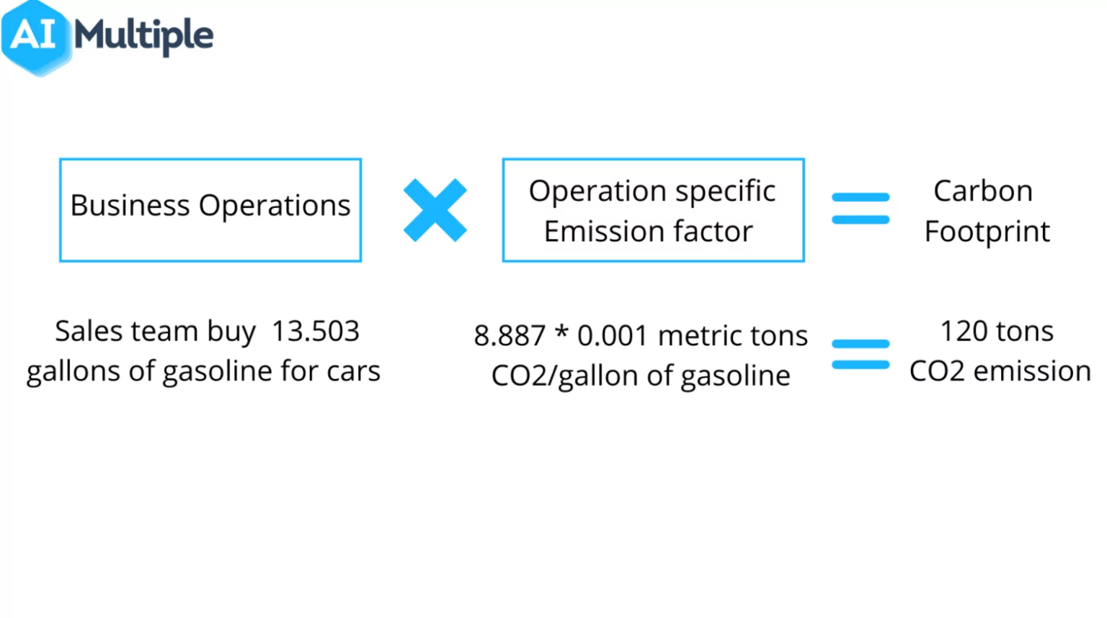
‘To effectively apply this formula, we divide the task of calculating carbon footprint into four main parts, namely, identifying business operations, collecting data on each business operation, determining operation-specific emission factors, and performing the final calculation and interpretation.’
Source: Görkem Gencer (2022) AIMUltiple, https://research.aimultiple.com/carbon-footprint-calculation/

An example: CF for the main stages of transformation of textile articles (clothes and household linen). Values refer to kgCO2eq/kg of textile articles, the sum of the processing step represents the CF of 1 kg of textile fully processed in Turkey and sold in France
Country | Impact fibres | Impact Transformation | Impact Preparation & Distribution | Impact Utilization in Franc | Impact End-of-Life Stage | Total
Turkey | 7.56 | 25.14 | 0.82 | 2.44 | 0.24 | 36.21
Payet, J. (2021), p. 14

Life cycle assessment (LCA)

The life cycle assessment (LCA) is a methodology for assessing environmental impacts at all stages of a product's life cycle. For example, cradle-to-grave is the full Life Cycle Assessment from resource extraction ('cradle') to use phase and disposal phase ('grave') (see the diagram below).

Example Life Cycle Assessment (LCA) stages diagram

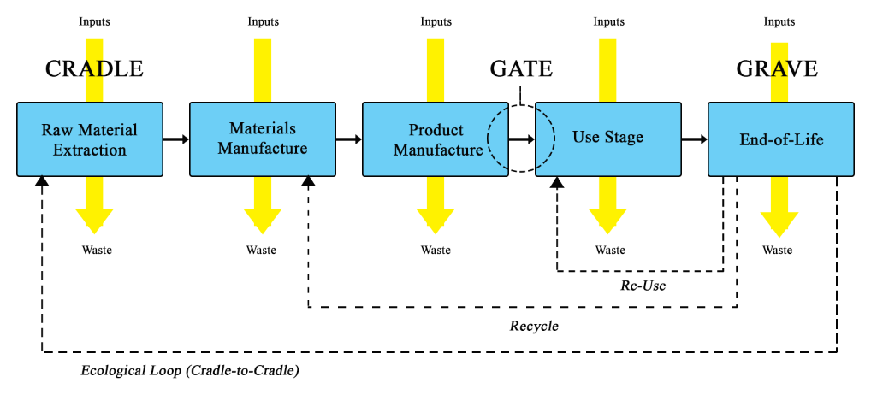
Source: Wikimedia Commons, https://commons.wikimedia.org/wiki/File:Example_Life_Cycle_Assessment_Stages_diagram.png

In the textile industry, life cycle assessment (LCA) is used to evaluate the environmental impacts of textile products, from raw material extraction, through fibre processing, textile manufacture, distribution and use, to disposal or recycling. LCA is an important tool for the research and development process, product and process design, and labelling of textiles and clothing. It is a scientific approach standardised by the International Organisation for Standardisation for the objective life cycle assessment, and environmental impacts.

The following international standards are concerned:

ISO 14040, Environmental Management - "Life Cycle Assessment - Principles and framework. European Committee for Standardization, Brussels. 1997
ISO 14041, Environmental Management - Life Cycle Assessment - Goal and Scope Definition and Inventory Analysis. European Committee for Standardization, Brussels. 1998
ISO 14042, Environmental Management - Life Cycle Assessment - Life Cycle Impact Assessment. European Committee for Standardization, Brussels. 2000
ISO 14043, Environmental Management - Life Cycle Assessment - Life Cycle Interpretation. European Committee for Standardization, Brussels. 2000,
ISO 14050:1998, Environmental Management — Vocabulary

According to ISO 14040, an LCA study contains the following steps:

Goal and scope definition
Inventory analysis
Inventory analysis (ISO 14041) aims at determining the flows of material and energy between the technical product system and the environment. Data for input and output flows are collected for each unit operation and aggregated for the whole life cycle. Input flows could be resources such as raw materials, energy or land and output flows could be emissions to air, water or land.
Impact assessment
Life Cycle Impact Assessment, LCIA, (ISO 14042) aims at evaluating the significance of potential environmental impact based on the result of the life cycle inventory analysis.
Impact assessment includes: Definition of impact categories and category indicators: Common impact categories (and indicators) are:
• Stratospheric ozone depletion (CFC-11 equivalents)
• Climate change (CO2 equivalents)
• Photo-oxidant Creation Potential (Ethylene equivalents)
• Acidification (SO2 equivalents)
• Eutrophication of waters (PO4 equivalents) (Nord, 1995)
Classification, and assignment of Life Cycle Inventory (LCI) results to the impact categories
Characterization, and calculation of the size of the impact indicators. This is done by using characterization factors for the substances.
After characterization comes to an optional step called weighting (ready-made LCIAs) (ISO 14042). It is used when there is a need to compare the relative importance of various impact categories
Interpretation
The interpretation (ISO 14043) step means that conclusions are drawn and that recommendations can be given.

LCAs performed in the textile sector, some example

Title, country | Purpose (and method) | Main conclusions
Resource and Environmental Profile Analysis of a Man-Made Apparel Product: Woman’s Knit Polyester Blouse; Franklin Associates Ltd, USA, (Franklin, 1993) | To assess the energy requirements and environmental emissions and solid waste for the life cycle of a polyester blouse | Consumer use corresponds to 86% of the life cycle energy needs. Cold wash with line drying reduces laundering energy by more than 90%. Air emissions and solid waste are also very dominant in the consumer phase
The ecology of hotel textiles and textile services – an LCA study on best available applications and technologies (Kalliala, 1997). | To find the present best ecological solutions for hotel textiles and services, to develop an ecological index for products and processes with “Best Available Technology”. | The use of polyester-cotton sheets has fewer environmental consequences than the use of 100% cotton sheets.
The life cycle of cotton rolls for hand drying, Denmark, (Schmidt, 1999) | Simplified LCA on cotton-based towel rolls used for 10 000 hand drying | The laundering process is the most important process related to environmental burdens
Source: Dahllöf, L (2004)

Environmental impact assessment. How do we find out our possible environmental impact? A way to asses

What is the environmental impact of our present production and what is the possible impact of the future (planned) production and product? How we can have the answer to it? To do it, we have to go through a self-assessment, elaborated in an Interreg project (ENTeR Expert Network on Textile Recycling (CE 1136), 2018).

We have to fill the following table to help to find an answer, evaluating the extraction, transport, and storage of the resources, the manufacturing/assembly, the storage of the finished product, its use and useful life, the waste transport and disposal and waste reuse/recycle both of the present and the planned product.
We are looking for the environmental impact of all these stages in concern of their energy consumption (1-low, 2-average or 3-high consumption), waste generation (1-little and no hazards,2- average waste of no especially high volumes or risks, 3-high volume, also hazardous); air pollution (1 – No air pollution at this stage; 2 – Some air pollution, but not considerably high; 3 – Considerable air pollution), water pollution (1 – No water pollution at the stage, 2 – Some air pollution under control, (treated), 3 – The process often pollutes water or high risk of that exists); soil contamination/usage (1 – No potential to contaminate soil, 2 – The process potentially pollutes the soil, but it is not likely, 3 – Frequent violation of norm).
Summing up the values in the row we receive the impact evaluation of the different stages (extraction, transport and storage of raw material/resource, production (manufacturing, assembly), storage and use of the finished product, and later waste management (transport, disposal, reuse/recycling). In every row the maximum value can be 15, which means the highest value of the environmental impact of the present/future product and the minimum value can be 5, indicating the best (that is the lowest possible) environmental impact.

Help table for environmental impact assessment

Environmental impact | Energy consumption |  |  | Waste generation |  |  | Air pollution |  |  | Water pollution |  |  | Soil contamination/usage |  |  | Total
Value of the  stage | 1 – Process or method with low  energy consumption | 2 – Average energy consumption | 3 – Large consumption | 1 – Little waste, no hazardous | 2 – Average waste, no specially  high volumes or risks | 3 – High volumes, also hazardous  waste | 1 – No air pollution at this stage | 2 – Some air pollution, but not  considerably high | 3 – Considerable air pollution | 1 – No water pollution at the  stage | 2 – Some air pollution under  control, (treated) | 3 – The process often pollutes  water or high risk of that exists | 1 – No potential to contaminate  soil | 2 – The process potentially pollutes  the soil, but it is not likely | 3 – Frequent violation of normal  or accidental soil contamination | Sum up the values in the row
Stages | Before/After |  |  | Before/After |  |  | Before/After |  |  | Before/After |  |  | Before/After
Extraction of
resources
Transport
of
resources
Storage of
resources
Manufacturing,
assembly
Storage of
finished
products
Use, useful life
Waste
transport
Waste disposal (if incineration)
Waste reuse/recycle

Source: ENTeR (2018) WP T2 Activity A T2.3. Pilot cases

What can we do? Places to look for materials and ideas

‘The European RREUSE network RREUSE is an international non-profit network representing social enterprises active in the field of reuse, repair and recycling. In 2019, RREUSE (Rreuse Activity Report, 2019) had 27 members across 25 European countries and the USA. RREUSE’s mission is to ensure that policies, innovative partnerships and the exchange of best practices promote and develop the role of social enterprises in the circular economy.

RREUSE members’ activities include:
— Advocacy at local, regional and national levels and sharing of best circular practices
— Awareness-raising campaigns, local and international projects and business support
— Collection, sorting and redistribution of used textiles and clothing
— Collection, repair and reuse of electronics, furniture and bulky items
— Reuse of other household items such as bric-a-brac, books, toys and paint
— Operating second-hand retail outlets

In December 2019, RREUSE published a vision (Rreuse, 2019) for Europe on how to achieve a more inclusive and circular textile sector that prioritises reuse and emphasises the role of social enterprises in the value chain as part of the solution. ‘

Source: Andreas Köhler, David Watson, Steffen Trzepacz, Clara Löw, Ran Liu, Jennifer Danneck, Antonios Konstantas, Shane Donatello, Giorgia Faraca (2021), p. 44)

Link to Rreuse: https://rreuse.org/

What to do with our waste? How to find useful waste for my company?

If we decide to change we have to take steps. We have to find out what steps to do. What to do with our waste? There is an online database collecting materials (coming from waste or not) and technologies to help to find the elements to give a second life to your waste. It is the Material Match Making Platform - a tool that helps match materials and technology needs. It was launched by the Life M3P project (2016-2019). You can start sharing your waste after creating an account on the platform.

The link to the Material Match Making Platform is:: https://www.lifem3p.eu/en/

How to use Material Match Making Platform?

1. Register yourself
2. Register your company
3. Register waste offered by your company
4. Search and look at waste useful for your company
5. Ask for found waste

Textile waste and available technologies for textile waste treatment in Hungary

Textile waste producing
The Hungarian textile industry produces only a small amount of waste compared to other industries and the national economy as a whole. According to data from the Hungarian Waste Information System (OKIR), between 2010 and 2017, there was not a single textile company among the 100 largest waste producers in Hungary.

OKIR can be found on the next link: http://web.okir.hu/en/tart/index/82/Legal_regulations

Good to new: National and EU level Environmental Information Systems

OKIR - the National Environmental Information System (Országos Környezetvédelmi Információs Rendszer)
The vast majority of environmental information (e.g. on air, surface and groundwater, waste, etc.) is stored in a single central database, the National Environmental Information System (OKIR), which provides for the monitoring of the state and use of the environment, the collection, processing and recording of data on pressures and uses.

E-PRTR (European Pollutant Release and Transfer Register)
The European Pollutant Release and Transfer Register (E-PRTR) is a European-wide database that aggregates data on significant environmental releases from installations and organisations.

EIONET (European Environment Information and Observation Network)
it is a partnership network of the European Environment Agency (EEA) and 39 EEA members and cooperating countries, which provides timely and quality-assured data, information and expertise on the state of the environment and pressures on our continent. EIONET is developed and coordinated by the EEA in close cooperation with the so-called national contact points.

The practice of ECO-labels

EU-Ecolabel
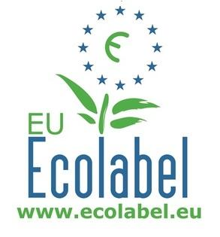

The European Union's eco-labels are awarded only to products and services of high quality and outstanding environmental performance, and in Hungary, they are awarded by the Herman Ottó Institute Non-profit Ltd.

As concerns the textile and garment industry it is pity that ‘only 7200 textile and clothing products have been awarded the label out of more than 75,000 certificates issued for 24 product groups. (Source: Dr. Kokasné Dr. Palicska, Lívia (2022)).

Process

What should you do if you decide to get an ecolabel?

Pre-application phase: to understand the EU Ecolabel
Step 1: Contact Your Competent Body (in Hungary it is the Hermann Ottó Institute Non-profit Ltd
Step 2: Register your goods or service in the online EU Ecolabel catalogue (ECAT)
Step 3: Build your application dossier with your goods and service description and testing
Step 4: Submit your application and pay the fees
Step 5: Assessment
Step 6: Application approval and licence award
Step 7: Communicate about your EU Ecolabel goods and services

The process of application (in Hungary):

- Manufacturers, service providers, distributors, and importers submit their applications to the responsible institution (in Hungary it is the Hermann Ottó Institute Non-profit Ltd).
-The institution checks and assesses the conformity of the product with the criteria based on the documents and certificates submitted. In case of compliance, the Organisation will issue a written decision and a written proposal to the Minister.
-The Minister decides whether to accept the application and award the EU Ecolabel.
-If the application is accepted, the Minister authorises the institution to enter into a contract with the applicant and to arrange for the information to be published on the EUEB website.
-The institution publishes the award of the Ecolabel on the Ecolabel website.
-The institution shall regularly check the compliance of the Ecolabel-led products at least once during the contract period. In the event of non-compliance with the EU Ecolabel criteria, the Organisation shall take the initiative to suspend or withdraw the use of the label from the Minister.
-The Minister decides on the suspension or withdrawal of the EU Ecolabel.
The EU Ecolabel application form (Application Pack) from the EU Ecolabel website (http://www.ecolabel.eu) under the product group criteria.

Criteria
Criteria to obtain ecolabel:

Fees
The costs to obtain an ecolabel include an application fee, an annual fee, on-the-spot check inspection fee.

A non-refundable application fee covering the administrative and control costs of the expert assessment of the application must be paid at the time of application. An application fee shall also be payable for the submission of a new application necessitated by a change to the Eco-label criteria for a product group. The duration of monitoring of the application: 2 months from the date of acceptance of the application.

In the case of a successful application, an annual fee will be payable for the use of the eco-label from the date of its award.

The Ltd. and, if necessary, the expert appointed by it shall carry out regular checks on compliance with the terms of the eco-label contract, but at least once during the contract period. The audit may also include an inspection of the applicant's premises and production processes. The costs of the on-the-spot check shall be covered by an inspection fee.

In 2022 the fees used to be:

Ecolabel fees, 2022
 | Application and renewal fee |  |  | Extension and modification fee |  |  | Annual fee |  |  | Inspection fee
 | Standard | SMEs, 0perators in developing countries s | Microenterprises | Standard | SMEs, 0perators in developing countries s | Microenterprises | Standard | SMEs, 0perators in developing countries s | Microenterprises | Europe | Outside Europe
Hungary* | 400.000 HUF + VAT | 140.000 HUF + VAT | 80.000 HUF + VAT | 400.000 HUF + VAT (when the criteria change) - 50% (when the criteria are prolonged without changes) | 140.000 HUF + VAT (when the criteria change) - 50% (when the criteria are prolonged without changes) | 80.000 HUF + VAT (when the criteria change) - 50% (when the criteria are prolonged without changes) | 350.000 HUF + VAT | 200.000 HUF + VAT | 90.000 HUF + VAT | 50.000 HUF + VAT | 20.000 HUF + VAT
Portugal
Turkey
*Note: Application/Renewal fees are reduced by 30% for those applicants who are registered under EMAS (Eco-Management and Audit Scheme) or by 15% for those applicants who are certified under ISO 14001. Reductions are not cumulative.

More information in Hungary on obtaining ecolabel:

https://okocimke.hu/eu-okocimke-megszerzese
http://www.hermanottointezet.hu/okocimke
http://www.hermanottointezet.hu/sites/default/files/palyazati_tajekoztato_unios_2021.pdf
Information on ecolabel at the EU level:
http://www.ecolabel.eu

OEKO-tex label – MADE IN GREEN
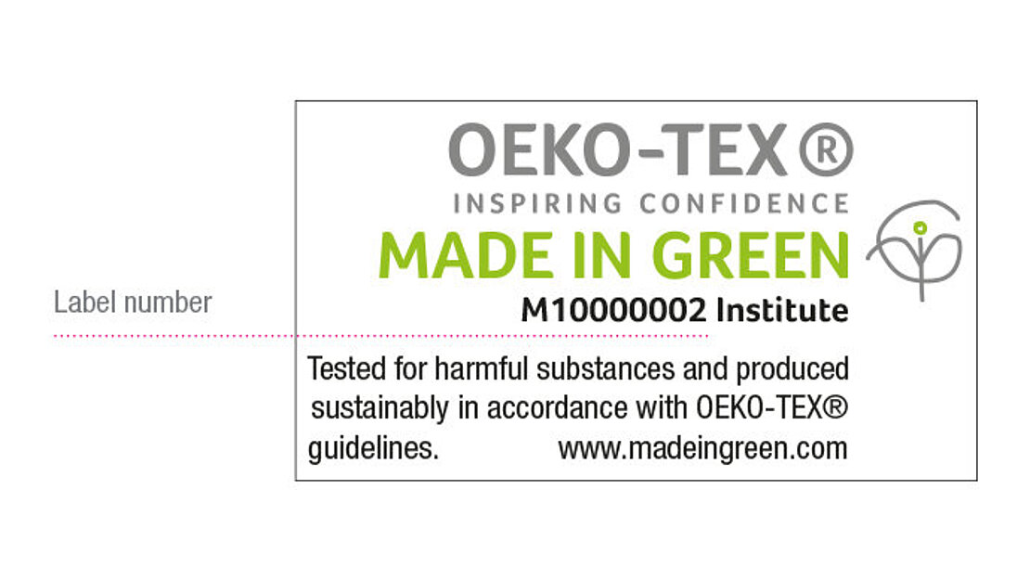
MADE IN GREEN by OEKO-TEX® is a traceable product label for textiles (e.g. clothing, home textiles) and leather products, including non-textile/leather components (e.g. accessories). The MADE IN GREEN product identifier indicates that the product has been tested for harmful substances. This is achieved by certification to STANDARD 100 or OEKO-TEX® LEATHER STANDARD. It also guarantees that the textile or leather product has been manufactured using sustainable processes under socially responsible working conditions. This is done through certification according to OEKO-TEX® STeP. The unique product identifier allows the product to be traced. This makes it possible to identify where the different stages of the product's manufacture took place (see more at oeko-tex.com).
The content of the label is uniquely complex and its validity can be verified by anyone.

New customers may apply among others for STANDARD 100 or ECO PASSPORT by OEKO-TEX®.

STANDARD 100 by OEKO-TEX® is a label and product certification for textiles tested for harmful substances and it indicates to end-users that the product is free of harmful substances and is therefore safe and skin-friendly.

Conditions for testing, certification and licensing according to STANDARD 100 by OEKO-TEX® can be downloaded here: https://www.oeko-tex.com/importedmedia/downloadfiles/STANDARD_100_by_OEKO-TEX_R__-_Standard_en.pdf

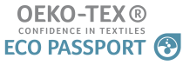
ECO-PASSPORT by OEKO-TEX® Certification for chemicals used in sustainably produced textiles. It is a chemical and excipient certification. With this certificate, the STANDARD 100 by OEKO-TEX® can be obtained at a lower cost.

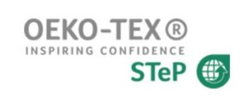

The STeP by OEKO-TEX® standard assesses the entire manufacturing process of textile and leather products from a sustainability perspective. The six modules of the standard contain very stringent environmental and social requirements and auditors examine around 350 questions during self-assessment and on-site visits. Following the assessment, the company's performance is graded in one of the 3 levels of the standard and the company receives recommendations to improve its sustainability performance. Companies that do not have a chemical register or an environmental management system cannot be certified. Nor can companies where a child or forced labour, sexual violence or blocked emergency exits are present be certified. Once the grounds for exclusion no longer apply, the company can reapply for certification.
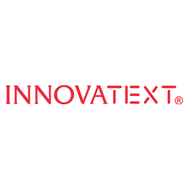
Innovatext – the Hungarian member of OEKO-TEX®.
The OEKO-TEX® itself consists of 17 independent institutes in Europe and Japan and their contact -offices all over the world, which are at your disposal for textile and leather tests or other technological tasks. The Hungarian partner is Innovatext, the independent Textile Engineering and Testing Institute. It provides a wide range of services, including quality controls, environmental protection consulting, laboratory tests and certifications according to OEKO-TEX® standards.

Among the 17 partners, there is a Portuguese partner as well, it is the CITEVE - Technological Centre for the Textile and Clothing Industries of Portugal, a research and testing institute with headquarters in Portugal and offices in 4 continents, supporting the competitiveness of textile, clothing and technical textiles companies. It has an intense service of testing, based in cutting-edge laboratories offering tests according to 900+ standards.

On the website of the OEKO-TEX there is also a possibility to verify the validity of an OEKO-TEX® label by entering the label number into the ‘Label Check’ https://www.oeko-tex.com/en/label-check.

What do the labels say? How to choose a label?

You can listen to the interview on the topic only in Hungarian.

KOSSUTH Radio 2022, broadcast on 27 September.
In the programme, the representative of the Association of Conscious Consumers and the CEO of INNOVATEXT Zrt. advised on how consumers who are aware of sustainability should choose clothes, and where to look for textile products manufactured under ethical conditions.

Link to the broadcast
https://mediaklikk.hu/radio-lejatszo-kossuth/?date=2022-09-28_09-05-00&enddate=2022-09-28_11-00-00&ch=mr1

Starting at 9:34 and ending at 9:56

GOTS (Global Organic Textile Standard)

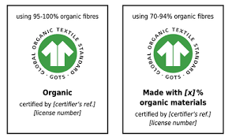
The term organic refers to the use of at least 95% natural fibres, while ‘made with organic’ refers to the use of at least 70% natural fibres. ‘As a processing standard, certification according to GOTS begins with the first processing stage of textile fibres. For example, for cotton, ginning is the first processing stage, at which seeds are removed from cotton bolls’ (Source: https://global-standard.org/certification-and-labelling/who-needs-to-be-certified/first-processing-stages)
Some parameters are equally applicable to all processing stages under GOTS certification, like:
Social Criteria, Ethical Business Behaviour and Environmental Management.

GOTS is comprised of four member organisations, namely OTA (USA), IVN (Germany), Soil Association (UK) and JOCA (Japan).

EMAS (Eco-Management and Audit Scheme)
By monitoring and systematically improving the environmental performance of your business make sure that the resources you use to protect the environment, and improve your reputation.
To obtain EMAS registration, you must:
- conduct an environmental review
- adopt an environmental policy and programme in which you involve employees and external stakeholders
- establish and implement an environmental management system
- prepare an environmental statement
- get the environmental management system verified and the environmental statement validated by an environmental verifier

Link to EMAS registration:

https://europa.eu/youreurope/business/running-business/developing-business/emas-registration/index_hu.htm

Textile label
Textile labels are mandatory for products intended for sale to an end consumer. To sell textile products in the EU, you must comply with EU labelling requirements. Textile products must be labelled with a clear indication of the composition of the used textile fibres and the non-textile components of animal origin. The label must include the composition of the fabric - in descending percentage order. Clear and legible text and uniform fonts (same font, size and style) should be used. The textile composition information has to be separated from other information like how to care for the product. The text must be translated into all official national languages where the textile products are sold. A textile product can only be described as "100%" or "pure" if it is composed exclusively of one type of fibre. However, you can for example refer to a 100% cotton shirt simply as "cotton". The official list of textile fibre names and their description (definition) is available in Annex 1 to Regulation (EU) No 1007/2011 of the European Parliament and of the Council of 27 September 2011 on textile fibre names and related labelling. Link to the regulation: https://eur-lex.europa.eu/legal-content/EN/ALL/?uri=CELEX:32011R1007#d1e32-12-1

Bibliography

Andreas Köhler, David Watson, Steffen Trzepacz, Clara Löw, Ran Liu, Jennifer Danneck, Antonios Konstantas, Shane Donatello, Giorgia Faraca (2021)) Circular economy perspectives in the EU Textile sector, Final report, Joint Research Centre (JRC), the European Commission, June 2021
CIRCE2020 Expansion of the Circular Economy concept in Central Europe local productive districts (CE 1125 –Central Europe Programme)
Dahlöff, L. (2004) Life Cycle Assessment (LCA) applied in the Textile Sector: the Usefulness, Limitations and Methodological Problems – A literature Review; Environmental Systems Analysis Chalmers Tekniska Högskola Göteborg, 2003; ESA-Report 2003:9 ISSN: 1404-8167 Revised Nov. 10th 2004, https://publications.lib.chalmers.se/records/fulltext/43818/43818.pdf
DigiPrime -Digital Platform for Circular Economy in Cross-sectorial Sustainable Value Networks (GA 873111 –Horizon 2020)
Dr. Kokasné Dr. Palicska, Lívia (2022)) in Csémi, Klára: Mit üzennek a cimkék? Riport a hiteles cimkékről, Divat&Marketing, 29.09.2022, https://divatmarketing.com/mit-uzennek-a-cimkek/
ENTeR (2018) Expert Network on Textile Recycling (CE 1136 –Central Europe Programme).
Franklin (1993) Franklin Associates Ltd, Resource and Environmental Profile Analysis of a ManMade Apparel product (Woman’s knit polyester blouse), American Fiber Manufacturers Ass., 1993
Gencer, Görkem (2022) 4 steps to calculate the carbon footprint of your organisation, AI Multiple, September 2022https://research.aimultiple.com/carbon-footprint-calculation/

Gustav, Sandin & Greg M., Peters (2018) Environmental impact of textile reuse and recycling. A review, Journal of Cleaner Production
https://www.researchgate.net/publication/323423640_Environmental_impact_of_textile_reuse_and_recycling_-_A_review
ISO 1400, Environmental management systems – Specification with guidance for use. European Committee for Standardization, Brussels. 1996
ISO/TR 14025, Environmental labels and declarations – Type III environmental declarations. International Organization of Standardization, Geneva, Switzerland. 2000
ISO 14040, Environmental Management - "Life Cycle Assessment - Principles and framework. European Committee for Standardization, Brussels. 1997
ISO 14041, Environmental Management - Life Cycle Assessment - Goal and Scope Definition and Inventory Analysis. European Committee for Standardization, Brussels. 1998
ISO 14042, Environmental Management - Life Cycle Assessment - Life Cycle Impact Assessment. European Committee for Standardization, Brussels. 2000
ISO 14043, Environmental Management - Life Cycle Assessment - Life Cycle Interpretation. European Committee for Standardization, Brussels. 2000
Kalliala E., (1997) The ecology of hotel textiles and textile services, PhD thesis, Publication no 214, Institute of Fiber, Textile and Clothing Science, Tampere, Finland, 1997
Lena, G. (2021) EU strategy for Sustainable Textiles: Make it fit for SMEs, 9 November 2021, SMEunited, https://www.smeunited.eu/news/eu-strategy-for-sustainable-textiles-make-it-fit-for-smes
Life M3P (Material Match Making Platform) project

Payet, J. (2021) Payet, J. Assessment of Carbon Footprint for the Textile Sector in France. Sustainability 2021, 13, 2422. https://doi.org/10.3390/ su13052422
Schmidt A. (1999), The life cycle of cotton rolls for hand drying, dk-TEKNIK for Sophus Berendsen A/S, Copenhagen, Denmark. March 1999
The European Waste Framework Directive (Directive 2008/98/EC) (definitions of waste, recycling and recovery)

Legal Regulation

Directive 2008/98/EC of the European Parliament and of the Council of 19 November

Hungary: Act CLXXXV of 2012 on waste and Government Decree No 225/2015. (VIII.7) Korm on the conditions of activities related to hazardous waste. The Act covers all wastes, all preventive activities, waste management and waste management facilities.

See: https://modint.nl/2015-09-03/wp-content/uploads/2015/09/3.-recycled-fibers-dh-28.10.14.pdf.pdf

